Redwire Notes
Christopher Kalitin

Redwire Products

- Satellite busses:
  - Sabersat (VLEO)
  - Phantom (VLEO)
  - Thresher (LEO)
  - Hammerhead (LEO)
  - Mako (GEO)
- Space Systems
  - Avionics & Sensors & Star trackers (GNC stuff)
  - Power Generation
  - Structures & Mechanisms (deployables?)
  - RF systems (antennas too)
  - Payloads (?)
  - Payload adapters, ISS docking and berthing mechanism
  - Satellite Management / Modelling (Acorn 2.0)
  - Electric propulsion thrusters
- Space Manufacturing
  - Space Pharmaceuticals
    - July 2025, deal for royalties with Space Pharma
    - May 2025, awarded contact from Aspera Biomedicines for space-based research and analysis of a pharmaceutical (ADAR1 inhibitor)
    - Founded subsidiary SpaceMD to focus on scaling commercial drug development.
    - Many experiments previously flown to the ISS. 28 PIL-BOXes flown to date, to ISS aiui.
  - 3D Printing and Assembly (from one of the acquisitions)
  - Crop production (PONDS experiment for growing crops in space) and Advanced Plant Habitat
- Other
  - Partnership with iSpace on CLPS. Maybe they’re providing payloads?
  - Partner on Orbital Reef (Roll Out Solar Arrays, “digital engineering”, “internal outfitting”)
  - Sensors on Firefly’s Blue Ghost and IM-2 lunar landers.
  - Partnered with X-Bow Systems to build grnd=based rocket systems.

Acquisitions

- Adcole Maryland (Mar 2020) - Optical sensing, star tracking
- Deep Space Systems (Jun 2020) - Spacecraft design?
- Made In Space (Jun 2020) - Orbital additive manufacturing, zero-g printing
- Roccor (Oct 2020) - Solar arrays, booms, hines, antennas, RF
- LoadPath (Dec 2020) - satellite structures, launch adapters, thermal management components, deployable structures, etc.
- Oakman Aerospace (Jan 2021) - Spacecraft integration and testing and lab space
- Deployable Space Systems (Feb 2021) - Deployable solar arrays, structures, flexible and concentrator arrays, etc.
- Techshot (Nov 2021) - Biotech in 0g, bioprinting, on-orbit manufacturing.
- QinetiQ Space NV (Oct 2022) - Belgium-based satellite design and dev. Computers, power control and distribution, terminals. They built the international berthing and docking mechanism.
- Hera Systems (Aug 2024) - Small sat technologies for defense industry. ~$15M annual revenue before acquisition.
- Edge Autonomy (Jan 2025) - Drone manufacturer in defense.

Acole and Deep Space Systems merged in June 2020 to form Redwire.

Deep Space systems was part of Lockheed’s original bid for Orion in 2006. Founded 2001. It worked on Orion’s avionics system. They diversified into “satellite-ready cameras”. They were bidding on CLPS around 2018 and 2019, apparently the “main contactor” what happened there?

In August 2025 (now) Redwire won a contact for a long range reconnaissance (LRR) prototype for the US Army. Apparently also using satellite capabilities. This came out of Edge Autonomy.

This contact is for the Stalker UAS. “Advanced sensors, secure communications, autonomous mobility features, and modular payload configurations for mission-specific requirements.”

Executives are buying shares annually, around 1e5 to 1e6 dollars worth each time. https://x.com/scotto2050/status/1955712434964193384

Todo:
- Find satellite bus customers
- Find historic contact awards for reference
- Chart of awarded vs bid contacts (by value since they don’t give individual contacts) (eh just use ScottO’s chart)
- Full historic revenue, net income and cash (eh)
- Look into Edge Autonomy Q2 impact and revenue
- Founding of Redwire (origin merger of Adcole and Deep Space Systems)
- Look into their electric propulsion thruster

This is really the opposite of my usual investing philosophy. It is an exponentially growing sector, but not quite following wrights law or any fundamental underlying pattern. It’s just growth of little individual programs.

Historic Contracts

- USAF Research Laboratory
  - Dec 2025
  - 5 Year $45M contactor for design, dev, and testing of prototype “mission critical technologies”
  - https://redwirespace.com/newsroom/redwire-awarded-45-million-contract-from-air-force-research-laboratory-afrl-to-advance-enhanced-space-based-capabilities-for-the-warfighter/
- NASA
  - Mar 25 2025
  - 4 PIL-BOXes to the ISS
  - https://redwirespace.com/newsroom/redwire-awarded-nasa-contract-to-expand-pharmaceutical-drug-development-in-space-for-future-commercialization/
- Maxar
  - Jul 2025
  - 2x ROSA wings for Gateway’s PPE
  - https://www.businesswire.com/news/home/20250702438974/en/Redwire-Successfully-Deploys-the-Most-Powerful-Roll-Out-Solar-Arrays-Ever-Built-Prepares-for-Major-Delivery-in-Fourth-Quarter
- Thales Alenia
  - Apr 15 2025
  - International Berthing & Docking Mechanism for ESA Lunar I-Hab Gateway module
  - https://spacenews.com/redwire-wins-darpa-contract-for-vleo-demonstration/
- OHB Italia / ESA
  - May 2025
  - On-board computer (OBC) for ESA Comet Interceptor
  - https://redwirespace.com/newsroom/redwire-successfully-delivers-onboard-computer-for-esas-comet-interceptor-mission-to-study-pristine-comet/
- ESA
  - Avionics / OBC for Next-Generation Gravity Mission
  - https://www.biospace.com/press-releases/redwire-awarded-contract-to-provide-critical-avionics-technology-for-multinational-earth-observation-satellite-constellation?utm_source=chatgpt.com
- Aspera Biomedicines
  - 2025
  - PIL-BOX for ADAR1 inhibitor investigation
  - https://redwirespace.com/newsroom/redwire-awarded-contract-from-aspera-biomedicines-to-investigate-cutting-edge-cancer-treatment-in-space/
- NASA Tipping Point Program
  - 2025
  - Prototype funding for Mason Martian / Lunar manufacturing technology
  - $12.9M
  - https://redwirespace.com/newsroom/redwire-receives-nasa-approval-to-advance-cutting-edge-manufacturing-technology-for-building-infrastructure-on-moon-and-mars/?utm_source=chatgpt.com
- Boeing
  - Jan 13 2025
  - 4th pair of ISS IROSA wings
  - https://redwirespace.com/newsroom/redwire-successfully-delivers-fourth-pair-of-roll-out-solar-array-wings-for-iss-power/?utm_source=chatgpt.com
- European Defense Contactor
  - Aug 27 2024
  - Flight-proven RF payloads built in Longmont Colorado, the facility they got when Roccor was acquired
  - https://redwirespace.com/newsroom/redwire-selected-to-provide-advanced-rf-payloads-to-a-leading-european-defense-contractor-expanding-rf-offerings-to-overseas-markets
- NASA
  - Oct 2025
  - Cancelled On-orbit manufacturing demo
  - This is an example of a contact Redwire got that was cancelled later for an undisclosed reason
  - https://www.reddit.com/r/redwire/comments/17zq13z/looks_like_osam2_ao1_archinaut_might_be_canceled/
- USSF
  - Aug 2022
  - This is an inherited contact from Hera Systems
  - Contactor for Orion Space on USSF in-orbit refueling and in-orbit servicing experiment.
  - https://spacenews.com/orion-space-wins-u-s-space-force-contract-for-on-orbit-services-experiment/
- USSF
  - Feb 2025
  - Mako Spacecraft for USSF Tetra-6 mission. Subcontractor to Orion Space.
  - Earlier, Redwire delivered two Mako spacecraft for Tetra-5.
  - These will be the first GEO sats to be refueled.
  - https://redwirespace.com/newsroom/redwire-wins-follow-on-contract-to-deliver-third-mako-spacecraft-for-u-s-space-force/
- ESA
  - Feb 2025
  - Preliminary Spacecraft Design for upcoming astrophysics mission (imaging) based on the Hammerhead satellite platform.
  - Redwire Space NV is handling this (acquired company).
  - https://redwirespace.com/newsroom/redwire-awarded-contract-to-lead-study-for-the-european-space-agencys-next-dark-matter-mission/

Redwire got $21.9M in contacts from the Hera acquisition. See page 11.
Undisclosed acquisition price.
https://www.sec.gov/Archives/edgar/data/1819810/000181981024000111/exhibit991redwire9302024ea.htm

Space NV was previous owned by QinetiQ. QinetiQ is still around but Space NV is now owned by Redwire.

Space NV was acquired for 32M euros.

$109.8M in contact value from Space NV acquisition. See page 33.
https://ir.redwirespace.com/sec-filings/quarterly-reports/content/0001819810-24-000043/0001819810-24-000043.pdf

Satellite Bus Customers

Sabersat (VLEO)
Phantom (VLEO)
Thresher (LEO)
Hammerhead (LEO)
Mako (GEO)

Sabersat

Sabersat has only one announced contact, for the DARPA Otter program.

It’s an air breathing demonstration, also using electric propulsion?

400 kg, up to 7 years, > 150 km. 5 kW of solar!

Phantom

<300 kg, electric propulsion, <300 km altitude, up to 5 years.

Skimsat (with Thales Alenia)

https://www.thalesaleniaspace.com/en/press-releases/thales-alenia-space-and-qinetiq-pave-way-small-multimission-satellites-very-low

Also, Skimsat, which I think is from the Space NV acquisition (Belgium company).

Skimsat started in 2022, as a joint venture between Thales Alenia (67%) and Leonardo (33%). QinetiQ signed a contact to study VLEO satellites.

2.3 M euro program, Skimsat.

https://www.businesswire.com/news/home/20240513123174/en/Redwire-Announces-Development-of-New-European-Built-Very-Low-Earth-Orbit-VLEO-Spacecraft-Platform-called-Phantom

Sabresat was announced before Phantom. Phantom announced May 13 2024.

As of 2024, Skimsat is still alive and Redwire is working with Thales Alenia. Phantom is the satellite for the Skimsat program.

So Phantom only exists because it’s an offshoot of the Skimsat program, which Redwire got when they acquired Space NV from QinetiQ. Sabersat came first, and just based off looks, it is more suited for VLEO.

Thresher

320 kg, up to 3 kW, electric propulsion.

Meant for “Surveillance, space domain awareness, and tactically responsive space”

“Cyber security up to NSA Type-1 (TSAB)”

https://d1io3yog0oux5.cloudfront.net/_0c2d041e65810d4338ee5702c8cd879f/redwirespace/db/880/7579/transcript/Q3+2024+Transcript.pdf

https://www.insidermonkey.com/blog/redwire-corporation-nyserdw-q3-2024-earnings-call-transcript-1387449/

Mako and Thresher both came from the Hera Acquisition. (ctrl-f thresher in the transcript).

“Thresher is a LEO spacecraft currently on contract with an undisclosed customer, designed and built in the United States for operating in contested environments”

Wtf is the redwire master plan? Just acquire and kinda keep moving? Maybe MDA has a better plan? Rocket Lab’s master plan is clear, now what is Redwire doing? Flailing and buying companies and sorta growing? (revenues down)

Mao and Thresher are designed for the war fighter.

https://d1io3yog0oux5.cloudfront.net/_0c2d041e65810d4338ee5702c8cd879f/redwirespace/db/856/7581/pdf/Earnings+Presentation+9.30.2024.pdf

“Supports Move Up the Value Chain in select areas of emerging hybrid architectures”
They are trying to build satellites and not satellite parts, there’s some strategy.

Hammerhead

https://d1io3yog0oux5.cloudfront.net/_0c2d041e65810d4338ee5702c8cd879f/redwirespace/db/856/7581/pdf/Earnings+Presentation+9.30.2024.pdf

Hammerhead also comes out of the Belgium Space NV acquisition.

175 kg, 517 W solar, >450 km altitude, min 5 year lifetime, 23 years total on-orbit operation (sum).

The Proba-1 and -2 and -V missions used a similar satellite bus. These launched in 2001 and 2009 and 2013 respectively.

https://technology.esa.int/news/vacuum-soak-for-satellite-brain

These satellites had the same core avionics units, the Advanced Data and Power Management System, ADPMS.

ADPMS-2 first flew in 2009 (Proba-2). Then, ADPMS-3 was developed for further satellites.

At one point, Space NV began developing the Hammerhead platform based off the earlier Proba designs. This would be used on Proba-3 (ESA formation flying mission).

Remember Redwire rebranded Thresher and Mako, I think Hammerhead is a similar situation.

The ALTIUS mission uses Hammerhead, ESA approved this in 2017 with QinetiQ as prime contactor. So Hammerhead likely began before Redwire acquired the Belgium Space NV division.

https://www.esa.int/Applications/Observing_the_Earth/Altius/Contract_secures_build_of_ozone-monitoring_Altius_satellite

In Jan 2020, 75 million euro contact awarded to QinetiQ for the Altius satellite (Earth Observation).

Hammerhead for Altius: https://www.spacedaily.com/reports/Redwire_finalizes_Hammerhead_satellite_integration_for_ESA_ALTIUS_mission_999.html

Tech demo Hammerhead for ESA: https://redwirespace.com/newsroom/redwire-successfully-completes-integration-of-hammerhead-spacecraft-for-upcoming-european-tech-demonstration-mission/

LightShip Initiative (ESA) gave four industry studies to look into small sat platforms for Mars, as hosted payloads on LightShip, an electric propulsion tug that’ll go to Mars. Redwire bid an adapted version of Hammerhead for this.

Hammerhead lightship bid: https://redwirespace.com/newsroom/redwire-selected-by-european-space-agency-to-design-concept-for-revolutionary-mars-spacecraft/

Lightship: https://blogs.esa.int/to-mars-and-back/2024/09/17/seven-things-you-didnt-know-about-europes-tug-to-mars/

Proba-3 isn’t quite the hammerhead platform, it’s the same Belgium Space NV facility, and uses ADPMS-2 (Generation 2, important, gen 3 is for Hammerhead).

Redwire (Belgium) has the ARRAKIHS dark matter science mission. They are building a satellite around Hammerhead for this.

https://redwirespace.com/missions/hera/

Hera (mission to Didymos and Dimorphos) is using ADPMS-3. Dart used Redwire Rol-Out SolarArrays and digital sun sensors.

Mako

Two satellites, ESPA or ESPA-Grande class. GEO / MEO, rad hardened.

ESPA: 320 kg, 3 kW, 250-800 m/s, 3-5 years.

ESPA-Grande: 700 kg, 8 kW, 800-1200 m/s, 3-5 years.

Rendezvous and Proximity Operations.

Mako is being sued by Orion Space Solutions for the Air Force Research Laboratory. It will demo on-orbit refueling, cooperative inspection, docking, proximity operations, and advanced autonomy.

2 Mako’s currently being build for Tetra-5 mission.

Note Orion Space Solutions is the prime.

Acorn & DEMSI

https://redwirespace.com/newsroom/leading-the-next-frontier-in-digital-engineering-redwire-integrates-physical-and-digital-domains-to-prove-out-customer-solutions-using-real-time-modeling-and-simulation/

https://redwirespace.com/wp-content/uploads/2025/07/Acorn-2.0-Flysheet-1.pdf

Acorn is modelling and sim software build on MOdular Open System Architecture (MOSA) which is a DOD project.

It’s meant for concept development, performance optimization, risk analysis, etc.

DEMSI is a broader digital engineering environment for integrating commercial tools with Redwire’s Agent-baed Configuration Open-system Real-time Network (ACORN) framework.

DEMSI integrates commercial tools with Acorn 2.0.

https://redwirespace.com/newsroom/redwire-announces-major-release-of-acorn-2-0-software-product-expanding-its-ai-powered-digital-engineering-tools-for-aerospace-and-defense-customers

Acorn 2.0 release announcement Aug 12 2025.

DeepSat (earth obv company) has a contact with Redwire for Acorn 2.0.

Redwire just does everything, but not in any unified way. Rocket Lab also does everything, but in a unified way.

For the blog post, an apt comparison would be Rocket Lab’s and Redwire’s satellite platforms. One is a larger-scale strategy than the other.

Founding of Redwire

AE Industrial Partners, private equity firm led the merger of Adcole Space and Deep Space Systems.

Adcole, based in Massachusetts, specialised in design, manu, integration, and testing of spacecraft components.

Deep Space Systems (DSS), in Colorado, focused on systems engineering and spacecraft design. They were founded in 2001 and were a key contractor for CLPS.

Electric Propulsion Thruster

https://redwirespace.com/newsroom/redwire-developing-advanced-thruster-technology-to-offer-reliable-high-volume-production-to-support-dod-small-satellite-supply-chain/

Valkyrie thruster made in partnership with Phase Four (electric propulsion company) based on an existing design.

https://www.youtube.com/watch?v=mOrC0GlDNgk

Hall effect thrusters were developed by the Soviets in the 60s? US got it in the 70s.

H71M thruster is the NASA design that Phase Four and Redwire licensed for commercial use.

With the thruster they also develop a Power Processing Unit. “conditions and distributes” power to the thrust head, propellant management unit, engine management unit. So is this a satellite component or engine-specific component? I imagine the engine requires higher voltage than regular satellite components.

Redwire designed and manufactures the Power Processing Unit.

The propellant management unit modulates the propellant flow rate into the engine.

600 W. Valkyrie has the highest power to thrust ratio in this class. 34 mN, 1350 s ISP.

The entire system is 13 kg. I think this is including the Power Processing Unit.

They sell either an integrated unit with a base plate, or components.

March 2025 they completed a preliminary design review.

NASA designed the engine, now it’s Phase Four and Redwire’s responsibility to manufacturer it at scale.

Georgia Tech High Performance Electric Propulsion Lab validated the engine. Very tight plume, so the keepout box is smaller (and lower cosine losses?).

H71M is designed for deep space, rad hardened.

It can burn Xenon and Krypton. Apparently the only thruster that can do this.

Companies have asked about using it in Cislunar space. And they’re using it for VLEO.

Steve Kiser and the other guy at this talk both worked at the USAF on space stuff. Starlink satellites have to manoeuvre out of the way of space debris 275 times per day. 10,000 conjunction warnings per day, versus 2 per week a couple decades ago.

Q2 2026, 22-25 per month production capacity.

Steve Kiser says Power Processing Units are the limiting factor for most electric propulsion projects. He keeps emphasizing that this is what Redwire is providing.

https://www.spacevoyaging.com/news/2024/04/05/darpa-awards-phase-four-14-9m-for-low-earth-orbit-electric-propulsion/

Apr 2024, Phase Four got a $14.9 M contract from DARPA for VLEO air-breathing electric propulsion. This is also part of DARPA’s Otter Program.

Valkyrie is optimized for ESPA-class satellite constellations. ~300 kg.

Phase Four also has a Radio-Frequency Thruster, their Maxwell series. This uses RF energy to ionize propellant into plasma (no electrodes required), then the plasma is accelerated through a magnetic field generated by permanent magnets. This is the engine type being used for the DARPA Otter Program.

https://aviationweek.com/space/commercial-space/phase-four-says-its-rf-thruster-matches-hall-effect-performance

Maxwell Block 3 has 250-800 W, 600-1300 s ISP, 8-18 mH thrust using Krypton. It is propellant agnostic and can operate on xenon, krypton, iodine, water vapour, nitrogen, or oxygen.

https://www.researchgate.net/figure/Major-elements-of-a-Hall-thruster-string-9_fig2_268479234
PPU is for engine itself, not a general satellite component.

Founding of Edge Autonomy - AE Industrial Partners

All defense tech for Europe (sats and drones) are built in Europe by European subsidiaries.
https://youtu.be/AXIyHb46m2g?si=Fk8xQH8UMYqBmYfk&t=1082

https://www.youtube.com/c/EdgeAutonomy/about

Edge autonomy was born of a Sep 2021 merger of Jennings aeronautics and UAV factory. Jennings manufacturer the Stalker series and the VXE30 VTOL and has a 100k sqft manufacturing facility in Riga.

Aug 2022, Edge Autonomy acquired Michigan based Adaptive Energy, they design and manufacture sold oxide fuel cells.

https://edgeautonomy.io/ae-industrial-partners-acquires-uav-factory/

AE Industrial Partners acquired UAV factory. Same firm that led the Adcole and DSS merger that spawned Redwire.

https://edgeautonomy.io/uav-factory-jennings-aeronautics-rebrand-as-edge-autonomy/

Edge Autonomy is also backed by AE Industrial Partners. It seems they were the ones in control of UAV Factory (bad financial position? Idk how they acquired it, they seem competent) and led the merger with Jennings.

Edge Autonomy Financials

Just going through RDW 25Q2 and ctrl-f’ing “Edge Autonomy”
Also looking at the pro forma Edge Autonomy financials

Page 15 - Tax Benefit

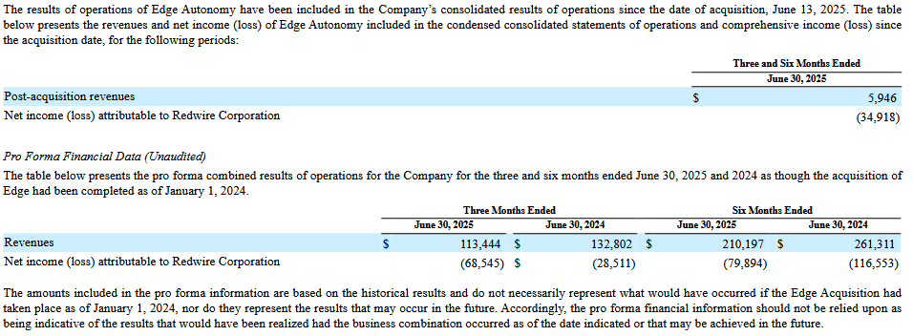

This section gives us Edge Autonomy impact to 25Q2 revenue and net income. $6M rev, -$35M income.

The lower table gives us pro forma illustrative data on what the combined company would have looked like if they had merged in 2024.

Grok says we can’t use this to extract historic Edge Autonomy results because of adjustments (Pro forma). Eg. goodwill, intangible assets accounting, and transaction costs. Maybe there exist more that I won’t catch, and it’s not too important for me.

In the sheet I got 24FY and 25Q1 results from Edge Autonomy, and they were profitable in 2024, and just barely in 2025.

Page 20 - Interest Expense

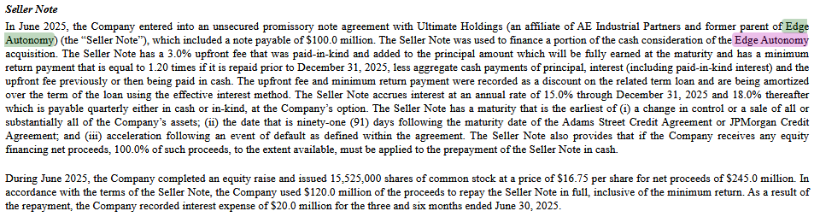

This section tells us they got a note payable of $100M from an AE Industrial Partners affiliated org. 3% fee upfront, 15% interest for 2025, 18% thereafter. Payable quarterly in cash or in-kind.

15,525,000 shares of common stock at $16.75 raised $245M. $120M of this used to repay the sellers note mentioned above. They paid it off early so didn’t reach the minimum return, so recorded an extra $20M interest expenses for Q2.

Page 23 - Tax Benefit

$32.6M in tax benefit associated with acquisition of Edge Autonomy.

It says it’s “the Company’s” deferred tax assets that are being executed, which is Redwire (not the combined company).

Page 28 - Edge Incentive Units

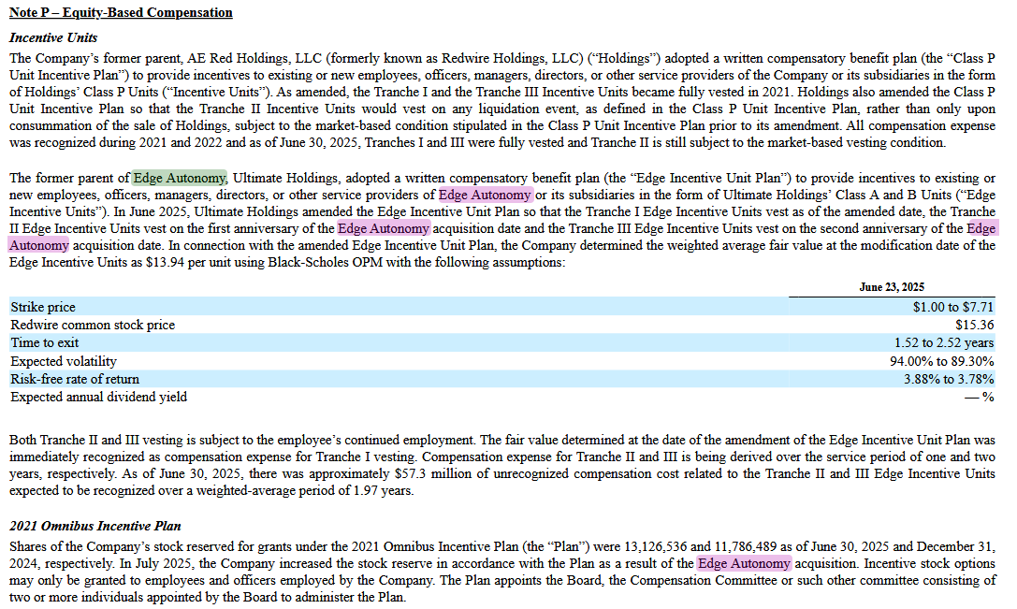

Edge Incentive Units “provide incentives for existing or new employees, officers, managers, directors, or other service providers of Edge Autonomy”

https://grok.com/c/f1fc19d5-8755-46eb-9efc-132b11d1011e

The strike price is the range at which the shares can be given to employees. Some tranches or grants at different prices, depending on the person I assume.

The shares were valued using the Black-Scholes OPM method at $13.94. Stock is currently $8.39.

$13.94 is the price used to recognize compensation expense for Tranche 1 and amortize expense for Tranches 2 and 3. The $57.3M unrecognized compensation cost over the next 2 years. $28.65M per year.

These expenses are recorded as operating expenses on the income statement. SG&A or R&D depending on what the employee works on.

Redwire has 13,126,536 shares of stock reserved for grants under the 2021 Omnibus Incentive Plan. Recently increased this stock reserve from 11,786,489. These are shares that can be issued to employees and officers of Redwire and subsidiaries. Total value of $110M at $8.39 per share.

RDW had ~66M outstanding shares in 24Q4. Up to 90M outstanding shares in 25Q2 holy fuck.

Outstanding shares include restricted shares (eg. unvested equity rewards) but exclude treasury shares (shares repurchased by the company).

Shares on the market are the publish float. Excludes shares held by insiders, restricted stock, and major shareholders (eg. controlling entities).

RDW Float is currently 56.36M shares, lots of room for dilution.

The 13M incentive shares account for 15% of current total outstanding shares.

Page 30 - Employee Stock Purchase Plan

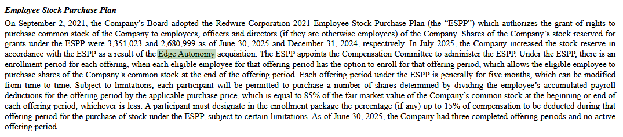

3,351,023 shares reserved for the employee stock purchase plan. Increased from 2,680,999 due to Edge Autonomy acquisition.

Page 36 - Ukraine Income

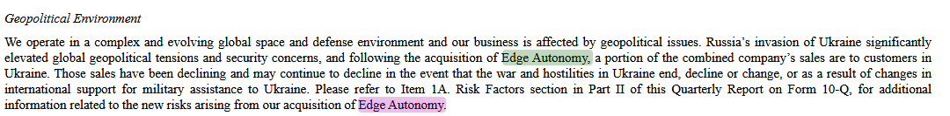

2024 profitability may have been due to Ukraine purchases, which have been declining and may continue to decline.

Page 37 - Reasons For Declining Financials

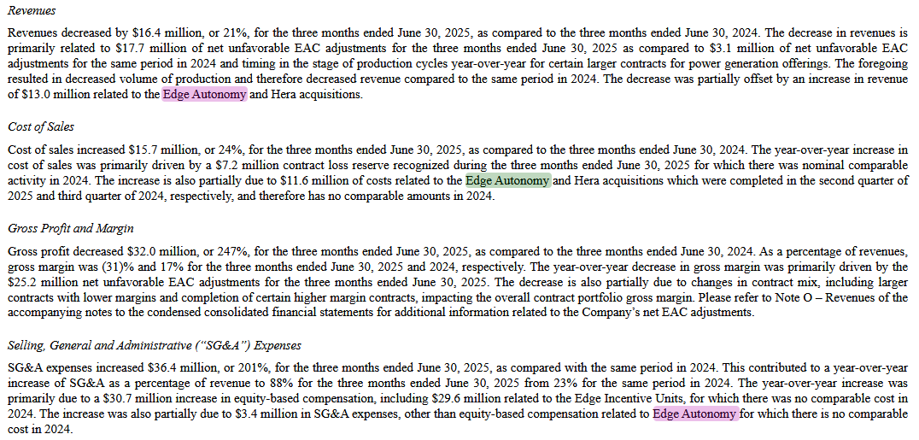

Decrease in revenues primarily related to $17.7M in net unfavorable EAC adjustments for 25Q2. $3.1M for 24Q2 for similar contracts?

$13M increase in revenue due to acquisitions of Edge Autonomy and Hera.

COGS increase $15.7 due to $7.2M contact loss recognized in 25Q2 (I’ll recognize this as part of EAC). Also $11.6M in costs for Edge Autonomy and Heraa acquisitions.

Gross profit decrease $32M in 25Q2. Driven by $25.2M net unfavorable EAC adjustments. Also the contract mix changed to include larger contracts with lower margins, and completion of certain higher margin contacts.

SG&A increased $36.4M 25Q2. $30.7M in equity-based compensation, of which there were $29.6M worth of Edge Incentive Units.

Interest expense increased $20.7 due to $20M interest expense mentioned earlier, repayment of Seller Note.

“$73.7 million of acquired contract value from the Edge Autonomy acquisition”

Book-to-bill (B/B) ratio is the ratio of new orders over revenue billed for a quarter.

Page 48, they say it’s all pro forma and unaudited.
“not necessarily indicative of the financial position or results of operations that would have actually occurred had the Edge Acquisition not been completed at or as of the dates indicated”

Page 50 - Ukraine

15% of Edge Autonomy sales for 24Q2 to 25Q1 inclusive were to customers in Ukraine. Declining and may continue to decline.

Sales here are a component of revenue.
https://grok.com/c/f1fc19d5-8755-46eb-9efc-132b11d1011e

Net Edge Autonomy Impact On RDW 25Q2

Revenue: +$13M (Edge Autonomy and Hera acquisitions)
Revenue: -$17.7M (EAC)

COGS: -$11.6M (Edge Autonomy and Hera acquisitions)

Gross Profit: -$25.2M (EAC)

SG&A: -$1.1M in equity-based comp (Redwire, not Edge Autonomy)
SG&A: -$29.6M equity-based comp in Edge Incentive Units

Interest Expense: -$20M (sellers note)

Tax benefit: +$32.6M (“in connection with the acquisition”)

Contract Assets?: +$73.6M (Edge Autonomy)

Positive Other Expense in 25Q1?

https://grok.com/c/3c56df1b-8ca9-4fc8-9e90-89f61d9a3be9

"The year-over-year increase was primarily due to a gain of $13.6 million recognized as a result of changes in the fair value of the private warrant liability during the three months ended March 31, 2025 as compared to a loss of $1.1 million recognized during the same period of 2024."

Redwire has warrants (financial instrument that gives the holder the right but not obligation to buy RDW at a given price). Warrant’s value dropped from $55.3M (end of 2024) to $6.7M (end of 25Q1) due to stock price falling from $7.07 to $4.90. Warrants are worth less when the stock price is lower, so Redwire’s warrants (their liability) decreased.

The warrants were likely part of the 2020 SPAC. Maybe we came up on the expiry date and they weren’t exercised? Idk and I don’t care too much. Lots of this bullshit type stuff with companies like this.

The -$46M in 24Q4 is due to a similar reason with warrants.

https://grok.com/c/39fe59c4-3741-442a-95e8-2c0e58eba934

EAC

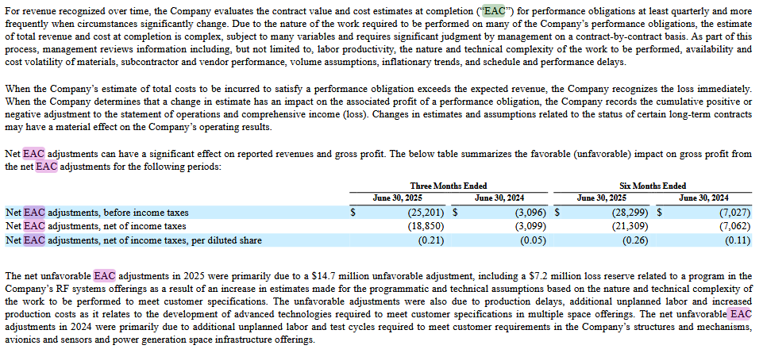

EAC (Estimate at time of completion) cost estimates are done every quarter.

Management creates an estimate of total costs to satisfy a performance obligation. If this estimate exceeds expected revenue, then the Company recognizes this as an EAC loss immediately. If there’s a profit, it recognizes this immediately.

Really, EAC is an adjustment given management assumptions around revenue and costs for given contract performance obligations. If costs are greater than expected, it shows as an EAC loss.

EAC is subtracted from revenue:
“Net EAC adjustments can have a significant effect on reported revenues and gross profit.”

Revenue Guidance

https://ir.redwirespace.com/news-events/press-releases/detail/172/redwire-corporation-reports-first-quarter-2025-financial
25Q1 forecast full year revenues (had the acquisition taken place on Jan 1 2025):
$535M to $605M

https://ir.redwirespace.com/news-events/press-releases/detail/191/redwire-corporation-reports-second-quarter-2025-financial
25Q2 forecast full year revenue (had the acquisition taken place on Jan 1 2025):
$470M to $530M

$70M drop, what happened?

25Q2 forecast of full year revenue of $385M to $445M.

“Due to uncertain timing of government contracting, at this time, the Company is withdrawing its previously provided Adjusted EBITDA forecast for the twelve months ended December 31, 2025.”
MFW

25Q1 Adjusted EBITDA forecast was $70M to $105M with positive free cash flow.

Now they’re certainly not going to be profitable. Maybe this is due to Edge Autonomy, with poor 25Q1 financials compared to profitable 2024.

So far, 2025 revenue is $123M, six months. So, ~$415M - $123 = $292M left to recognize this year given their estimates. This could be ~$146M Q3 and Q4.

Now To Decide

I’ve completed by dead reckoning Q3 predictions, now it’s time to decide.

Uncertainties:
- High Q3 transaction expenses
- Unknown “other expenses” (eg. stock warrants in 25Q1)
- High acquisition-related expenses (eg. interest)
- Low FY25 revenue post-acquisition (declining management forecasts)

Positives:
- >2x revenue increase due to Edge Autonomy acquisition
- Increased gross margin due to Edge Autonomy acquisition
- Majority of dilution and transaction expenses realized

This company has no grand strategy, they just acquire and continue on.

End of 24Q1 they were around $4 / share and Redwire itself (excluding Edge Autonomy) was in a better financial position. They had $87M in revenue and a -9% net margin versus $62M and -157% in Q2 2025 or $61M and -5% Q1 2025.

I see no synergy between Edge Autonomy and Redwire, similar to Redwire’s other acquisitions. Disparate satellite programs doing exactly the same thing. Their model is not to aggregate abilities of individual companies and increase efficiency and output, instead they keep a European and American division that don’t interoperate too much but share the same parent financials.

Reasons for Stock Price Spikes

https://stockanalysis.com/stocks/rdw/market-cap/

Jan 20 2025: Edge Autonomy Acquisition Announcement

$981M valuation to $1.5B in a day.

June 12 2025: Acquisition of Edge Autonomy completed

$1.49B to $2.42B in a day

Aug 6 2025: Q2 earnings poor due to acquisition

$1.95B to $1.36B in a day

Feb 20 2025: 5M warrants exercise at $11.5. $57M raised. Dilution.

2024 Q4 $52M non-cash loss due to this.

$1.58B to $1.20B over a couple days.

https://redwirespace.com/newsroom/redwire-announces-redemption-of-outstanding-public-warrants/

Will they need to raise more money? They’re loosing around $20M a quarter and have $78M in cash. Will need more money soon. Some quarters down $100M (2025 Q2) some down $3M (2025 Q1). All due to esoteric accounting-related events.

144.04M shares outstanding post acquisition. Not fully accounted for in Q2 SEC filings, probably due to timing.

Astra

https://youtu.be/WLCf88Qw8wc?si=GqF3TmlcErxpKbEe&t=736

Astra sells their ion thrusters for $0.5 M each. The plan was to make satellites, maybe this was part of the reason to go from ~100 kg to ~500 kg.

